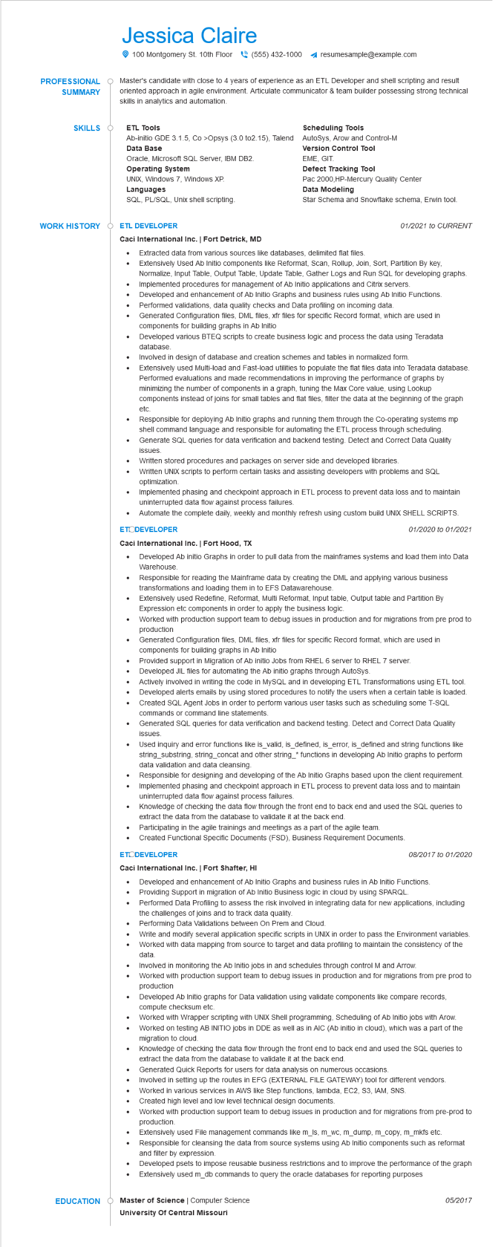
PROFESSIONAL
SUMMARY
Jessica Claire
100 Montgomery St. 10th Floor
(555) 432-1000 resumesample@example.com
Master's candidate with close to 4 years of experience as an ETL Developer and shell scripting and result oriented approach in agile environment. Articulate communicator & team builder possessing strong technical skills in analytics and automation.
SKILLS O
ETL Tools
Ab-initio GDE 3.1.5, Co >Opsys (3.0 to2.15), Talend Data Base
Oracle, Microsoft SQL Server, IBM DB2.
Operating System
UNIX, Windows 7, Windows XP.
Scheduling Tools
AutoSys, Arow and Control-M Version Control Tool
EME, GIT.
Defect Tracking Tool
Pac 2000, HP-Mercury Quality Center Data Modeling
Star Schema and Snowflake schema, Erwin tool.
Languages
SQL, PL/SQL, Unix shell scripting.
WORK HISTORY ETL DEVELOPER
Caci International Inc. | Fort Detrick, MD
• Extracted data from various sources like databases, delimited flat files.
01/2021 to CURRENT
Extensively Used Ab Initio components like Reformat, Scan, Rollup, Join, Sort, Partition By key, Normalize, Input Table, Output Table, Update Table, Gather Logs and Run SQL for developing graphs. Implemented procedures for management of Ab Initio applications and Citrix servers.
•
Developed and enhancement of Ab Initio Graphs and business rules using Ab Initio Functions.
Performed validations, data quality checks and Data profiling on incoming data.
Generated Configuration files, DML files, xfr files for specific Record format, which are used in components for building graphs in Ab Initio
Developed various BTEQ scripts to create business logic and process the data using Teradata database.
Involved in design of database and creation schemes and tables in normalized form.
• Extensively used Multi-load and Fast-load utilities to populate the flat files data into Teradata database. Performed evaluations and made recommendations in improving the performance of graphs by minimizing the number of components in a graph, tuning the Max Core value, using Lookup components instead of joins for small tables and flat files, filter the data at the beginning of the graph etc.
Responsible for deploying Ab Initio graphs and running them through the Co-operating systems mp shell command language and responsible for automating the ETL process through scheduling. Generate SQL queries for data verification and backend testing. Detect and Correct Data Quality issues.
Written stored procedures and packages on server side and developed libraries.
Written UNIX scripts to perform certain tasks and assisting developers with problems and SQL optimization.
• Implemented phasing and checkpoint approach in ETL process to prevent data loss and to maintain uninterrupted data flow against process failures.
Automate the complete daily, weekly and monthly refresh using custom build UNIX SHELL SCRIPTS. ETODEVELOPER
Caci International Inc. | Fort Hood, TX
•
01/2020 to 01/2021
Developed Ab initio Graphs in order to pull data from the mainframes systems and load them into Data Warehouse.
Responsible for reading the Mainframe data by creating the DML and applying various business transformations and loading them in to EFS Datawarehouse.
Extensively used Redefine, Reformat, Multi Reformat, Input table, Output table and Partition By
Expression etc components in order to apply the business logic.
Worked with production support team to debug issues in production and for migrations from pre prod to production
Generated Configuration files, DML files, xfr files for specific Record format, which are used in
components for building graphs in Ab Initio
Provided support in Migration of Ab initio Jobs from RHEL 6 server to RHEL 7 server.
•
Developed JIL files for automating the Ab initio graphs through AutoSys.
•
•
•
•
•
Actively involved in writing the code in MySQL and in developing ETL Transformations using ETL tool. Developed alerts emails by using stored procedures to notify the users when a certain table is loaded. Created SQL Agent Jobs in order to perform various user tasks such as scheduling some T-SQL commands or command line statements.
Generated SQL queries for data verification and backend testing. Detect and Correct Data Quality issues.
Used inquiry and error functions like is_valid, is defined, is_error, is defined and string functions like string_substring, string_concat and other string_* functions in developing Ab Initio graphs to perform data validation and data cleansing.
Responsible for designing and developing of the Ab Initio Graphs based upon the client requirement. Implemented phasing and checkpoint approach in ETL process to prevent data loss and to maintain uninterrupted data flow against process failures.
Knowledge of checking the data flow through the front end to back end and used the SQL queries to extract the data from the database to validate it at the back end.
Participating in the agile trainings and meetings as a part of the agile team.
Created Functional Specific Documents (FSD), Business Requirement Documents.
ETODEVELOPER
Caci International Inc. | Fort Shafter, HI
•
08/2017 to 01/2020
Developed and enhancement of Ab Initio Graphs and business rules in Ab Initio Functions.
Providing Support in migration of Ab Initio Business logic in cloud by using SPARQL. Performed Data Profiling to assess the risk involved in integrating data for new applications, including the challenges of joins and to track data quality.
Performing Data Validations between On Prem and Cloud.
Write and modify several application specific scripts in UNIX in order to pass the Environment variables. Worked with data mapping from source to target and data profiling to maintain the consistency of the data.
Involved in monitoring the Ab Initio jobs in and schedules through control M and Arrow.
Worked with production support team to debug issues in production and for migrations from pre prod to production
Developed Ab Initio graphs for Data validation using validate components like compare records, compute checksum etc.
Worked with Wrapper scripting with UNIX Shell programming, Scheduling of Ab Initio jobs with Arow. Worked on testing AB INITIO jobs in DDE as well as in AIC (Ab initio in cloud), which was a part of the migration to cloud.
Knowledge of checking the data flow through the front end to back end and used the SQL queries to extract the data from the database to validate it at the back end.
Generated Quick Reports for users for data analysis on numerous occasions.
Involved in setting up the routes in EFG (EXTERNAL FILE GATEWAY) tool for different vendors.
Worked in various services in AWS like Step functions, lambda, EC2, S3, IAM, SNS.
• Created high level and low level technical design documents.
Worked with production support team to debug issues in production and for migrations from pre-prod to production.
•
Extensively used File management commands like m_ls, m_wc, m_dump, m_copy, m_mkfs etc. Responsible for cleansing the data from source systems using Ab Initio components such as reformat
and filter by expression.
Developed psets to impose reusable business restrictions and to improve the performance of the graph Extensively used m_db commands to query the oracle databases for reporting purposes
EDUCATION O
Master of Science | Computer Science
University Of Central Missouri
05/2017

